Introduction to Telecommunication Networks
Telecommunication network is a set of telecommunications equipment, logically arranged (duzenlenmis) and interconnected (birbirine bagli), aimed at (amaclayan) providing telecommunication services.
It consists of :
- a set of information sources
- information receivers
- a network (for signal transmission and switching) (access points and access lines)
- individual sources and receivers are attached (bagli) over access points and access lines

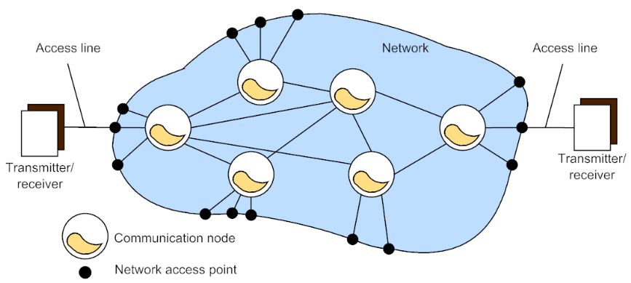
General model of a telecommunication network

• The access points are connected to subscriber terminal equipment (e.g. telephone, computer, etc.) by access lines (local loops).
Requirements for network:
1) At each moment (her an) there must be a possibility of creating a connection from one access point to any other access point.
2) Each user must be able to self-identify (kendi kendine belirlemek) their specified target
3) The network must be sufficiently powerful – it must provide a sufficiently large number of concurrent (Es zamanli) switching options.
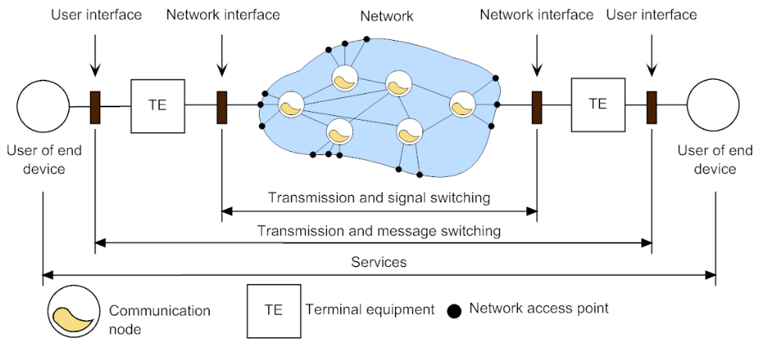
Communication Model

• Communication link creates a link (physical or logical), frequently between two terminals, in order to exchange information of a particular type (voice, data, video, …).
• The link between two terminals may have different characteristics depending on the selected service or network (analog telephone signal × digital data signal × client-server service).
• Communication links can be created by one-by-one interconnected (birbirine bagli) channels or as the virtual channel. Such link could be permanent (kalici) or could exist for a limited time.
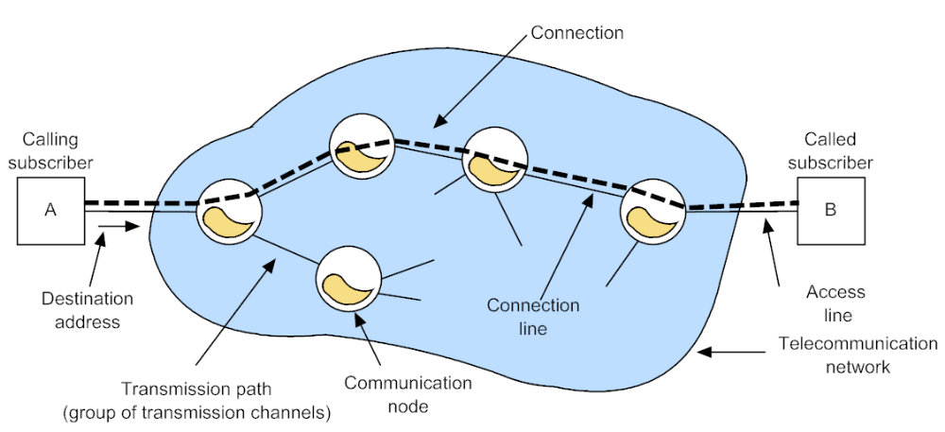
Communication link in telecommunication network

Connection-oriented and Connectionless Transmission

• Within the connection-oriented transmission, it is necessary to build a communication connection between both terminals according to the control information (e.g. phone number, address of the terminal) from the communication source.
• This type of communication has three phases (asama):
1) creation of the connection from the source to the destination and the reservation of the required network capacity,
2) user‘s data transmission,
3) termination (sonlandirma) of the connection and release (serbest birakma) of the network capacity.
• Example of the connection-oriented network: traditional telephone network.
• In the connectionless transmission, data are transmitted in the form of short data elements called packets that consist of a header and a payload (yuk).
• The header contains the destination address that is used to find the correct destination.
• There is no network capacity reservation, no guarantee of packet delivery but it is more efficient because the network capacity can be shared by many users.
• Example: Internet (IP networks).

Hierarchical and Nonhierarchical Structure of Telecommunication Network

• Traditional telephone networks have a hierarchical structure where each geographical area has its own primary level telephone exchange (local exchange). There also exist secondary level exchanges (tandem exchanges) that interconnect primary level exchanges and international exchanges. The bigger the distance between communicating users is the more exchanges of different levels take part in the data transmission.
• Example – international call: phone – local exchange – tandem exchange – international exchange – international exchange – tandem exchange – local exchange – phone.
• In the nonhierarchical network like IP network, there is not such a strict (kati) hierarchical structure. In general, there exist just the access network and the core (cekirdek) network. Each packet can travel through a different path.

Public and Private Networks
• Everybody can participate (katilmak) in the public network. Examples: PSTN – Public Switched Telephone Network, the Internet.
• Private networks are used only by privileged (ayricalikli) users. Example: networks of private companies or institutions (kuruluslar).
LAN, MAN and WAN
• Terms (terimler) LAN (Local Area Network), MAN (Metropolitan Area Network) and WAN (Wide Area Network) are often used in data networks for differently large networks.

Signaling
• The signaling is responsible for creating, maintaining (korumak, surdurmek) and terminating the connection in the connection-oriented networks. It helps to find a path and reserve a communication channel with a required capacity in the network.
• According to the signaling information, communication nodes learn which input port is necessary to be interconnected with which output port for a specific communication.
• The signaling is used to ensure a lot of user‘s services.
• The signaling information can be transmitted as a part of the data frame or separately by stand alone signaling messages.
• Types of the signaling:
1) subscriber signaling,
2) interexchange signaling.
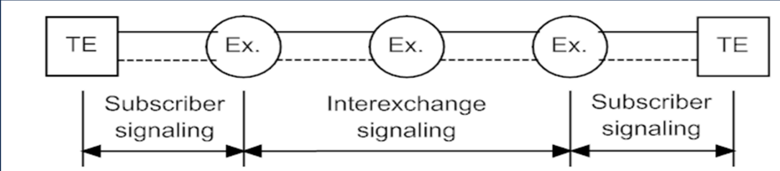
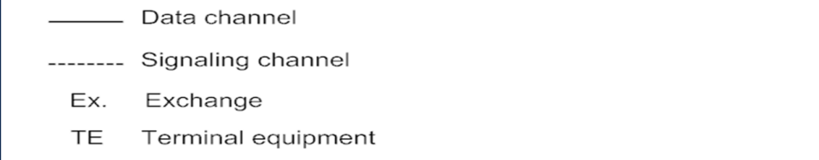
Subscriber and interexchange (karsilikli degisim) signaling

Ways of Signal Switching
• Communication nodes (telephone exchanges, routers, switches etc.) can handle (islemek, kullanmak) transported signals (analog signals, frames, packets, cells) differently according to used telecommunication technology.
1) Circuit switching
2) Message switching
3) Packet switching
1) Circuit Switching
• In the circuit switching networks, data is sent through a pre-built (onceden olusturulmus) channel. The channel can be built before the transmission by the signaling or it can be permanent.
• If there is enough capacity in the network to support a new communication channel, the channel is reserved for the whole communication. If there is not enough capacity, the connection is refused (reddedilmek).
• If the channel is already built, there is a guarantee of the reserved capacity. On the other hand, such network is not efficient because the capacity can‘t be dynamically shared among (arasinda) users. If a user has no data to transmit, blank (bos) data that does not contain any information is transmitted.
• Example: telephone networks
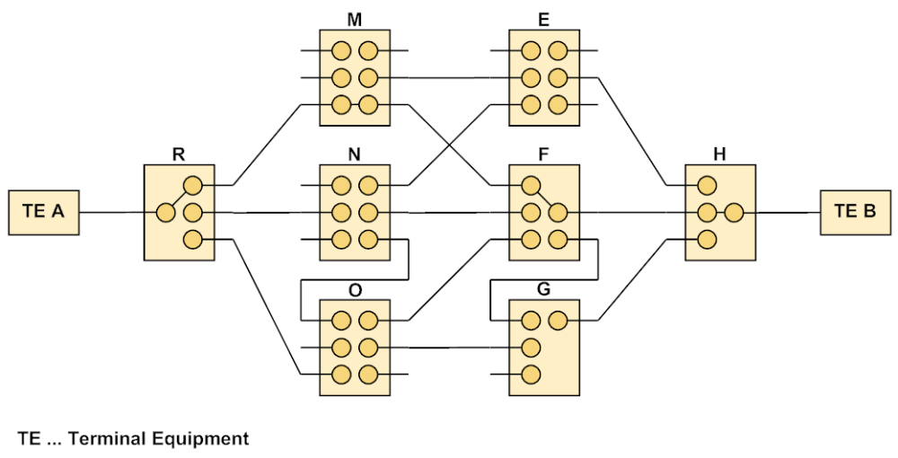
Circuit Switching

2) Message Switching
• In message switching networks, messages are equipped with a destination address and sent to the network without any capacity reservation and delivery guarantee.
• If there is a lot of traffic in the network, messages have to wait in communication nodes buffers (tampon). This can cause high transmission delay.
• Each message is transmitted independently from others – messages can travel through different paths.
• This type of transmission is not used in practice. It was replaced (yerini almak) by a packet switching.
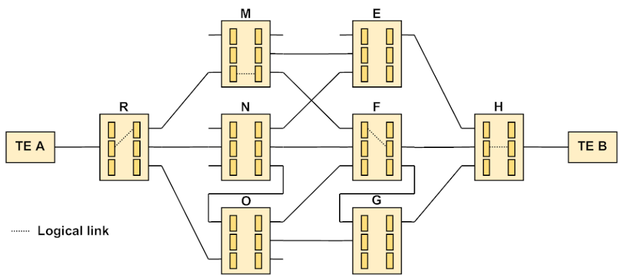
Message Switching

3) Packet Switching
• Packet switching is similar to message switching. The only difference is that messages are fragmented (parcalanmis, bolunmus) into smaller packets with the same or similar length.
• This type of transmission is effective (etkili) primarily (oncelikle) for a bursty traffic (patlamali trafik), for example, in computer networks.
• We differentiate two types of packet switching:
a) datagram service,
b) virtual channel service.

• With the datagram service, each packet can arrive to the destination with a different delay and in a different order.
• This is not a problem for delay insensitive (duyarsiz) applications.
• Example: “pure” IP network
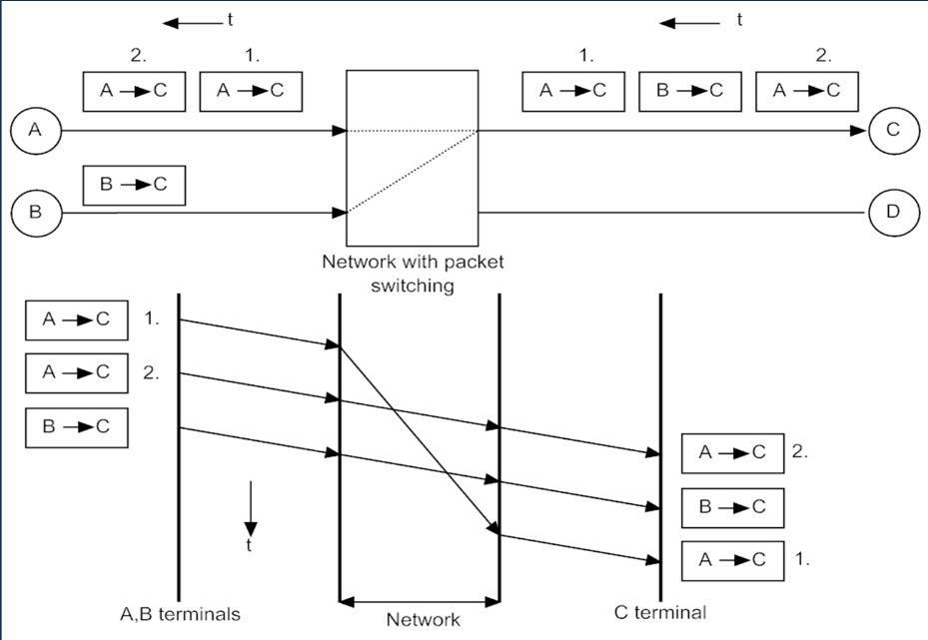
Packet Switching – datagram service

• Within the virtual channel service, it is necessary to build a virtual channel through the network. Each communication node creates a switching table to accomplish (yerine getirmek, yapmak) it. Data is still transported in the form of packets but all travel through the same path, in the same order, with the same delay.
• This method has features (ozellik) of both circuit switching and packet switching.
• This is advantageous for delay sensitive applications.
• Examples: Frame Relay, MPLS, ATM.
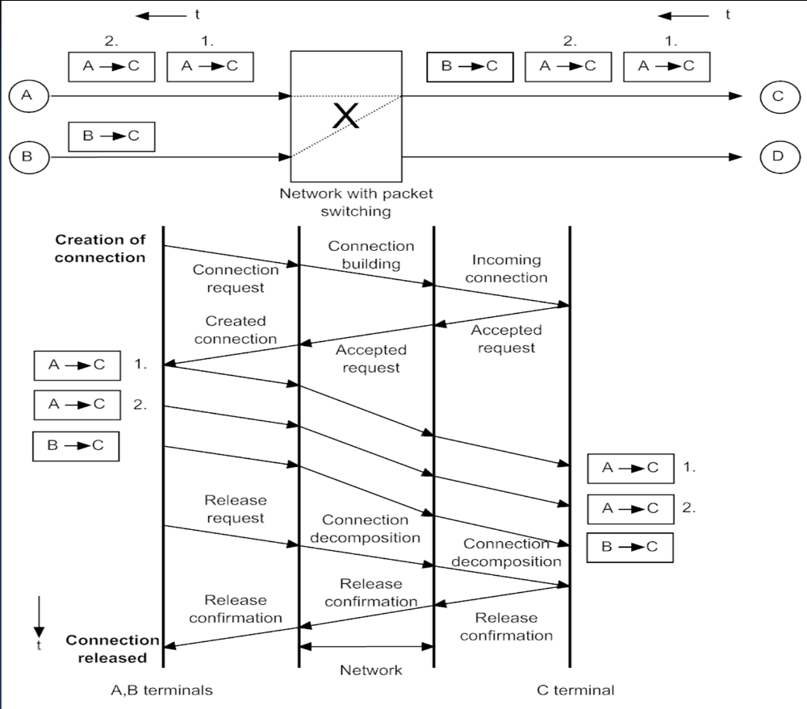
Packet Switching – Virtual Channel Service

